Experiment No :- 6
Laboratory Name :- Operating System Lab
Expriment title:- Paging simulation.
Problem Statement:-Write a Program to implement paging simulation.
Student Name :- Gayatri Rajendra Jagadale
Class :- SE(AI&DS)
Roll NO :- 20
Batch :- A

***********Program Input**************

#include<stdio.h>
int main()
{
int ms, ps, nop, np, rempages, i, j, x, y, pa, offset;
int s[10], fno[10][20];

printf("\nEnter the memory size -- ");
scanf("%d",&ms);
printf("\nEnter the page size -- ");
scanf("%d",&ps);

nop = ms/ps;
printf("\nThe no. of pages available in memory are -- %d ",nop);

printf("\nEnter number of processes -- ");
scanf("%d",&np);
rempages = nop;
for(i=1;i<=np;i++)
{
printf("\nEnter no. of pages required for p[%d]-- ",i);
scanf("%d",&s[i]);
if(s[i] >rempages)
{
printf("\nMemory is Full");
break;
}
rempages = rempages - s[i];
printf("\nEnter pagetable for p[%d] --- ",i);

for(j=0;j<s[i];j++)
scanf("%d",&fno[i][j]);
}
printf("\nEnter Logical Address to find Physical Address ");
printf("\nEnter process no. and pagenumber and offset -- ");
scanf("%d %d %d",&x,&y, &offset);

if(x<np || y>=s[i] || offset>=ps)
printf("\nInvalid Process or Page Number or offset");
else
{ pa=fno[x][y]*ps+offset;
printf("\nThe Physical Address is -- %d",pa);
}
}

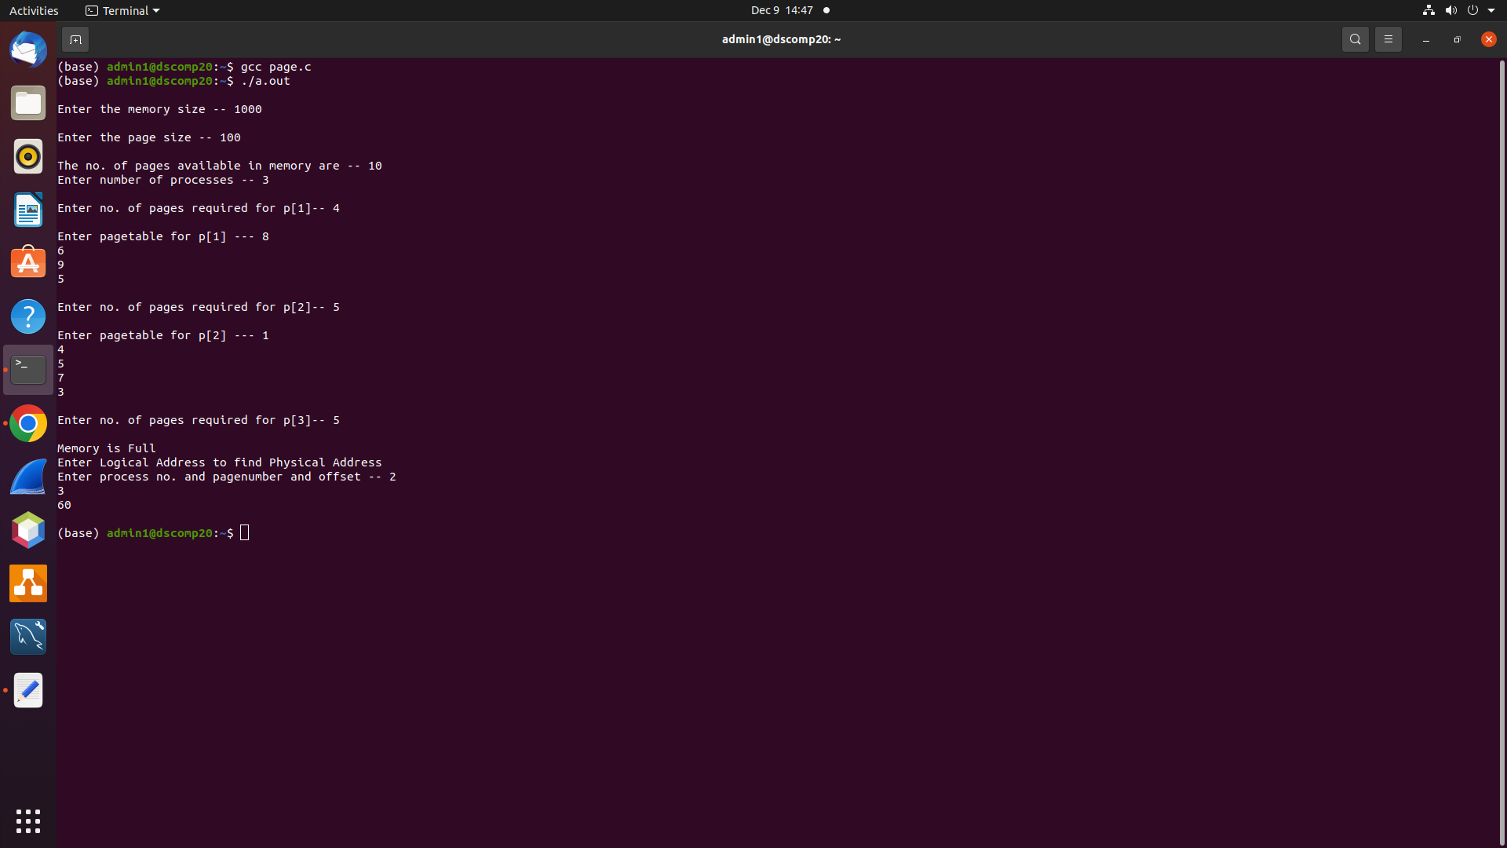
*************Program Output***************

